Lab 8 : Iceberg Architecture & Table Anatomy

Table of Contents

Table of Contents 2
Introduction 3
Learning Objectives 3
Prerequisites 4
Part 1 — Environment Setup 5
Step 1 — Install PySpark 5
Step 2 — Create the Spark/Iceberg Script 5
Part 2 — Create the Iceberg Table 7
Part 3 — Inspect the Physical Anatomy 8
Understanding the Anatomy 8
Knowledge Check 9
Troubleshooting 9
Symptom: ModuleNotFoundError: No module named 'pyspark' 9
Symptom: java.lang.ClassNotFoundException or Java errors 9
Next Steps 10
Conclusion 10

Introduction
Apache Iceberg is not a database engine; it is an open table format for huge analytic datasets. It brings SQL-like reliability and features to traditional data lakes.
To understand why Iceberg is powerful, you must understand how it stores data. Iceberg completely separates Data Files (the actual parquet files) from Metadata Files (which track snapshots, schemas, and partitions).
In this lab, we will use a local PySpark environment to create an Iceberg table, insert data, and visually inspect the underlying physical files to see the Iceberg architecture in action. (Later in the course, we will use Redpanda to stream real-time data directly into tables like this one!)

Learning Objectives
Upon completing this lab, you will be able to:
- Configure a basic local Spark environment with Iceberg capabilities.
- Create an Iceberg table and insert data.
- Navigate and understand the Iceberg directory structure (data vs metadata).
- Identify metadata.json, manifest lists, and manifest files.

Prerequisites
Before starting, ensure you have the following installed on your Ubuntu VM:
1. Python 3 & Pip Verify your Python environment:
python3 --version
pip3 --version

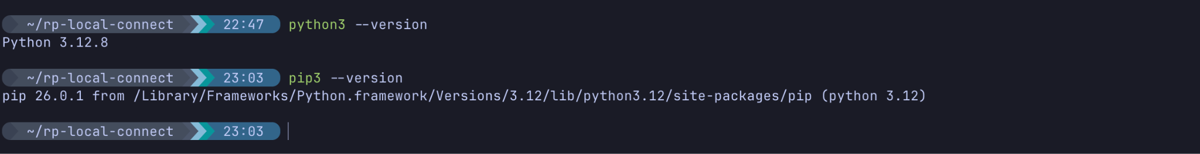
2. Java (Required for Apache Spark) Spark runs on the JVM. Install the default Java Runtime Environment (JRE):
Verify the installation:
java -version

3. Tree Utility We will use the tree command to easily visualize Iceberg's underlying physical directory structure. Install it via:
sudo dnf install tree -y

Part 1 — Environment Setup
We will use PySpark to act as our compute engine to interact with Iceberg.

Step 1 — Install PySpark
Create a new directory for this module and install PySpark:
mkdir ~/iceberg-labs
cd ~/iceberg-labs
pip3 install pyspark

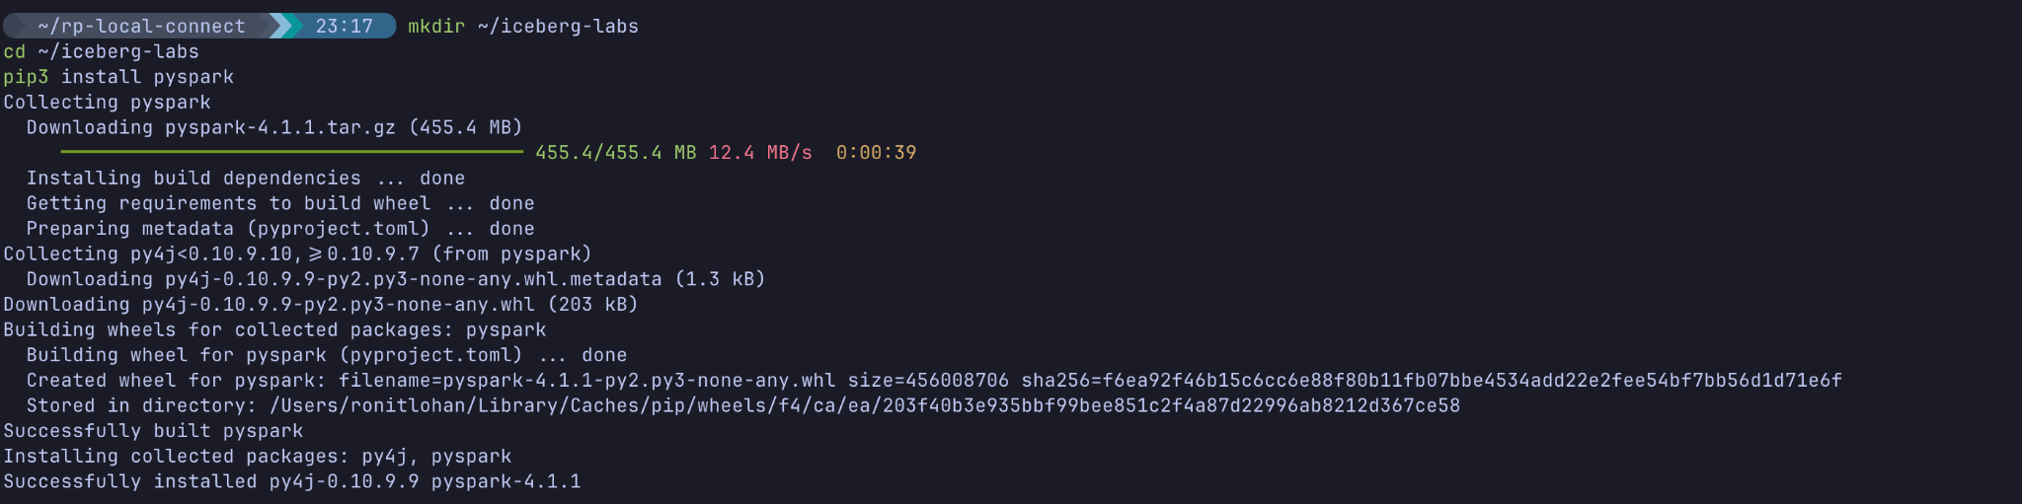

Step 2 — Create the Spark/Iceberg Script
We will write a Python script that initializes a Spark session with the necessary Iceberg dependencies and creates our first table.
Create a new file:
nano iceberg_init.py

Paste the following code:

from pyspark.sql import SparkSession
import os
print("Starting Spark and downloading Iceberg dependencies... (this may take a moment)")
# Initialize Spark with Iceberg configs using a local Hadoop catalog
spark = SparkSession.builder \
.appName("IcebergLab") \
.config("spark.jars.packages", "org.apache.iceberg:iceberg-spark-runtime-3.5_2.12:1.5.0") \
.config("spark.sql.extensions", "org.apache.iceberg.spark.extensions.IcebergSparkSessionExtensions") \
.config("spark.sql.catalog.local", "org.apache.iceberg.spark.SparkCatalog") \
.config("spark.sql.catalog.local.type", "hadoop") \
.config("spark.sql.catalog.local.warehouse", f"{os.getcwd()}/warehouse") \
.getOrCreate()
# Create a database and an Iceberg table
print("Creating Iceberg database and table...")
spark.sql("CREATE NAMESPACE IF NOT EXISTS local.db")
spark.sql("""
CREATE TABLE IF NOT EXISTS local.db.users (
id bigint,
name string,
signup_date date
)
USING iceberg
""")
# Insert initial data
print("Inserting data into the table...")
spark.sql("""
INSERT INTO local.db.users VALUES
(1, 'Alice', DATE '2023-01-01'),
(2, 'Bob', DATE '2023-01-02')
""")
# Show the data
print("Current Table Data:")
spark.sql("SELECT * FROM local.db.users").show()
spark.stop()

(Save and exit using Ctrl+X, Y, Enter).

Part 2 — Create the Iceberg Table
Run the script you just created:
python3 iceberg_init.py

(Note: The first time you run this, Spark will download the Iceberg runtime .jar files. This may take 30-60 seconds).
Expected Output:
Current Table Data:
+---+-----+-----------+
| id| name|signup_date|
+---+-----+-----------+
| 1|Alice| 2023-01-01|
| 2| Bob| 2023-01-02|
+---+-----+-----------+
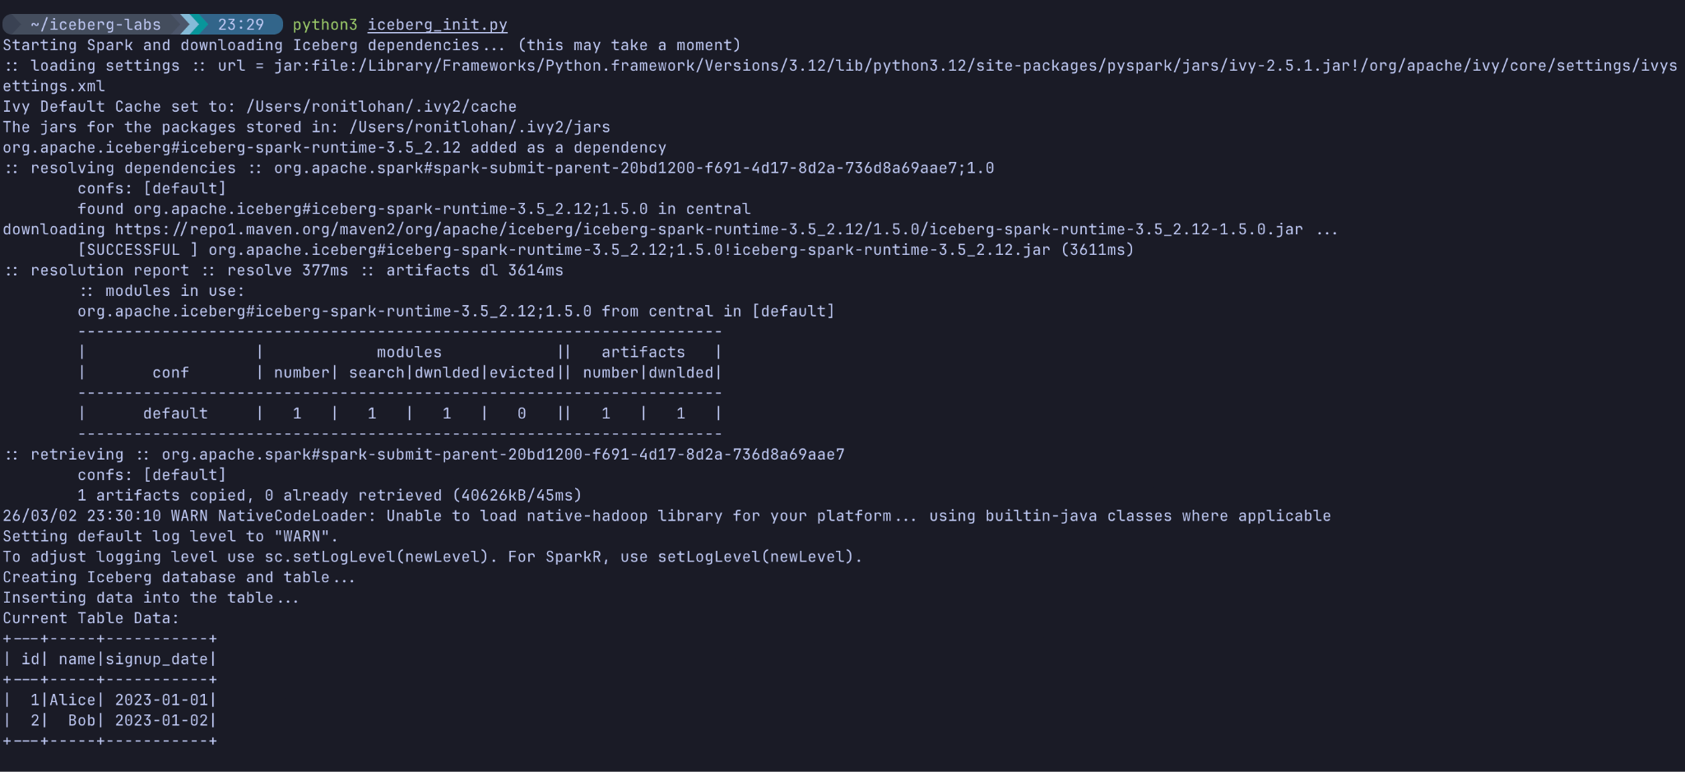

Part 3 — Inspect the Physical Anatomy
The script configured Iceberg to use a local directory named warehouse to store its files. Let's look at what Iceberg actually created.
Run the tree command to view the file structure:
tree warehouse/db/users
Expected Output:
warehouse/db/users
├── data
│ └── 00000-0-a1b2c3d4...parquet
└── metadata
├── 00000-7c2d1b...metadata.json
├── 00001-3f4a9b...metadata.json
├── snap-8172361823...avro
└── 8172361823-m0.avro
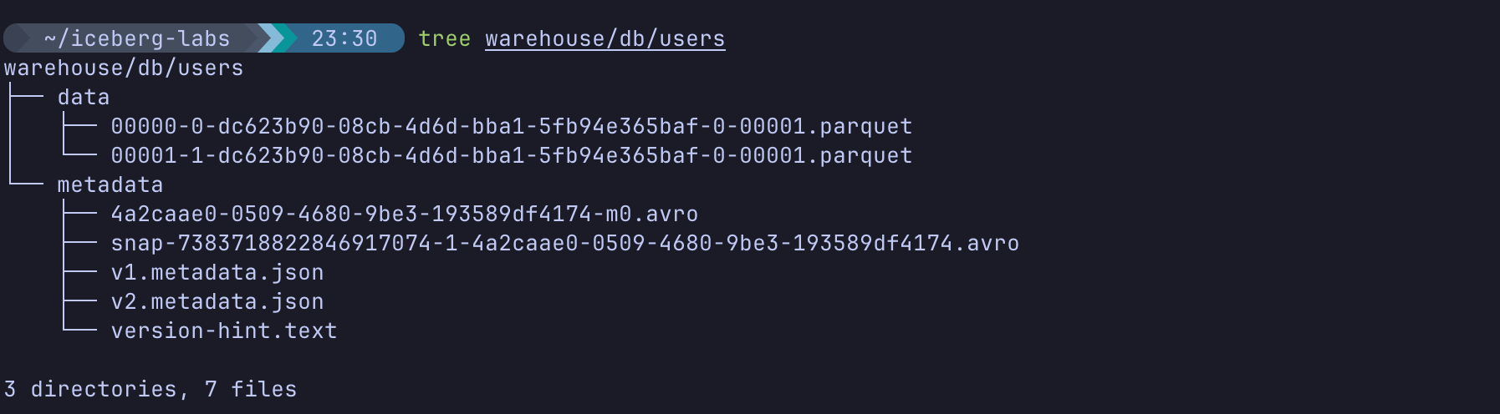

Understanding the Anatomy
Notice the strict separation of concerns:
- The data/ folder: Contains standard Parquet files. These are the actual rows you inserted. Because it's standard Parquet, any tool can read it.
- The metadata/ folder: This is the "brain" of Iceberg.
- metadata.json: The root of the table state. It tracks the schema, partition specs, and the current snapshot. Iceberg creates a new one every time the table changes.
- snap-*.avro (Manifest List): Tracks all the manifest files that belong to a specific snapshot.
- *-m0.avro (Manifest File): Keeps track of the individual Parquet data files, including min/max statistics for lightning-fast querying.
This metadata layer is exactly what allows Iceberg to perform ACID transactions and schema evolution on top of a raw data lake!

Knowledge Check
- Does Apache Iceberg process or execute queries?
- Answer: No, Iceberg is a table format. You need an engine like Spark, Trino, or Flink to execute queries.
- What file acts as the ultimate "source of truth" for the current state of an Iceberg table?
- Answer: The latest metadata.json file in the metadata directory.
- In what format does Iceberg store the actual data rows by default?
- Answer: Apache Parquet.

Troubleshooting

Symptom: ModuleNotFoundError: No module named 'pyspark'
Solution: Ensure you ran pip3 install pyspark successfully.

Symptom: java.lang.ClassNotFoundException or Java errors
Solution: Spark requires Java. Ensure Java is installed by running java -version. If it is missing, install it using sudo apt install default-jre -y.

Next Steps
Now that you have seen how Iceberg structures data physically, proceed to next lab. You will use this same table to demonstrate Iceberg's most powerful features: Schema Evolution and Time Travel.

Conclusion
In this lab, you created your first Iceberg table. By inspecting the physical directory structure, you demystified the "Lakehouse" concept. You saw firsthand how Iceberg brings database-like metadata (manifests and snapshots) to standard Parquet files residing in a data lake.

